Finally here comes the final assignment, website project. I had been doing Tocumwal for my first and second assignments which is HTML and CSS. However, I am doing Norfolk for the final assignment. This is the hardest assignment from this unit. I face a lot of problem and I did my best to figure it out. I had learned how to rotate the photo by Transform: rotate (90 degree); From one of the tutorial, we learned about the columns, so I insert a column on top of my website and it have 4 option which is go to bottom, home, history, and location. We have to do at least three pages for this assignment.

We did a sketch of the wireframe around week 7/8 . Soon, will use Adobe XD to make it. My laptop works more than 5 years and it couldn’t download the Adobe XD. However, I was using wireframe cc to do the job.

From the Mansi website (my reference link), you can see they put photo beside some words and some times there’s only one single big photo. Beside, they using beige as background so that their font can use darker color, same theory as using dark background. In my planning, I was thinking to make my navigation as horizontal because it can show my content faster than if I made vertical navigation. I am giving a border for the “Norfolk” to outstanding my tittle.

My references:

<http://pastamansi.com/>

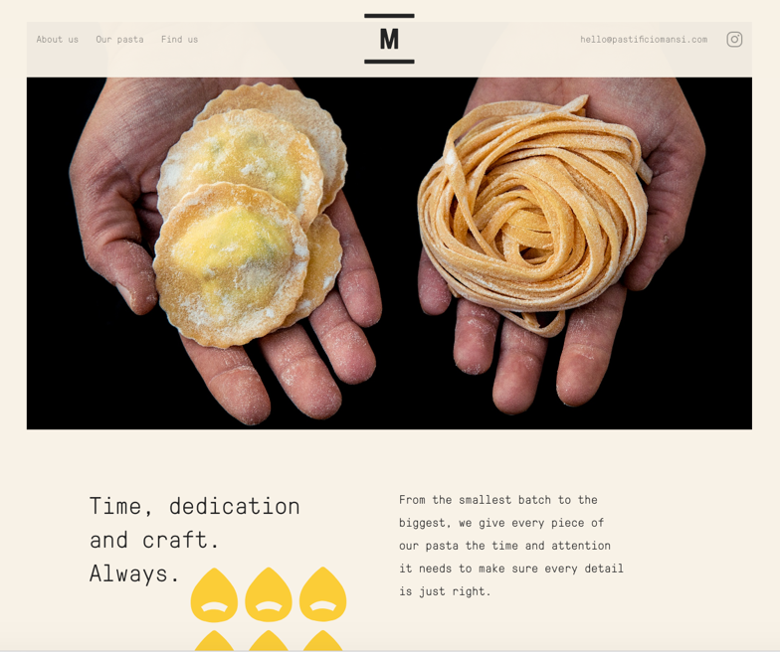

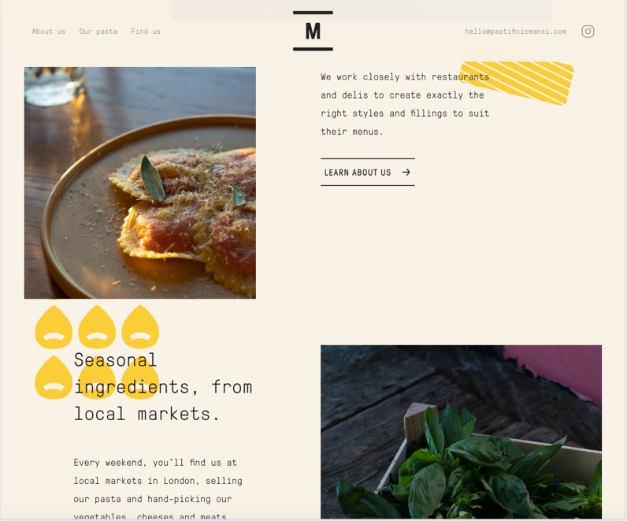

This is my first sketch:

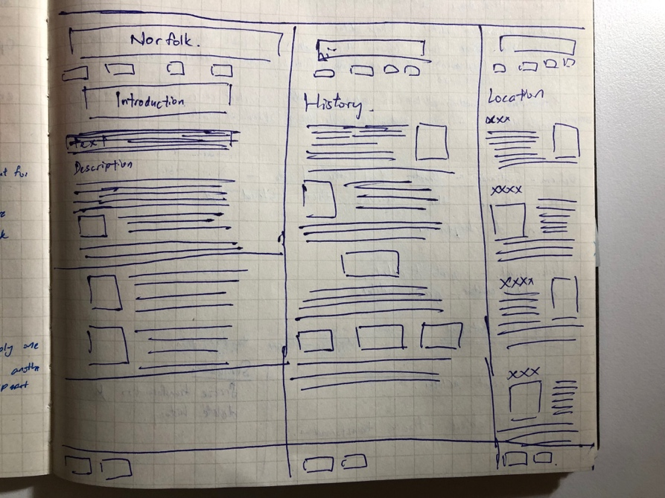

Therefore, I also go to Adobe colour to make my self a palette for this website. At first there’s a pink in my palette, but then I realize pink and green don’t really match. So I end up only using beige orange and green. However, the real reason I choose beige is because, in my research, Norfolk Island is a tiny Australian island in the South Pacific Ocean. It has lot’s of pine trees, jagged cliffs, sandy beaches. Cliffs and sand are beige, and pine trees are green. It was just a simple reason why I choose green and beige. As common sense, before you do everything, understanding of your client or project is a must. So I think these two color are reasonable to appear in my website.

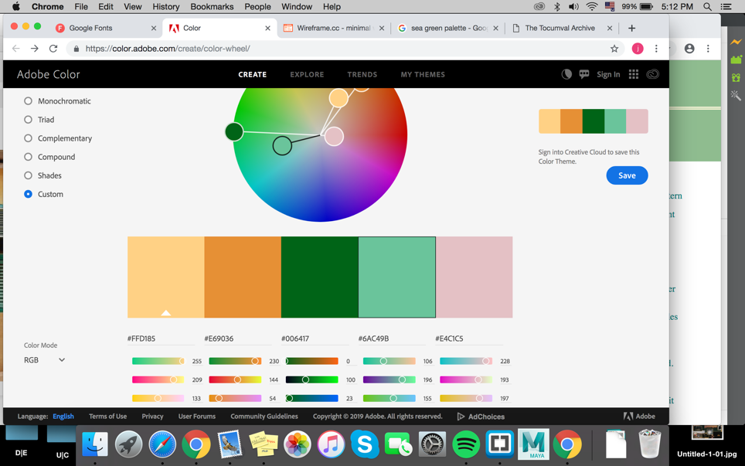

The final decision of the palate:

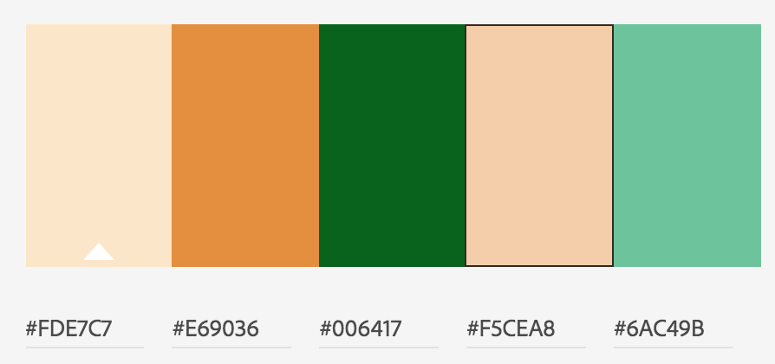

In the Location section, I style {width: 300px} for all images due to I think it should be big and clear since this is “Location” section.

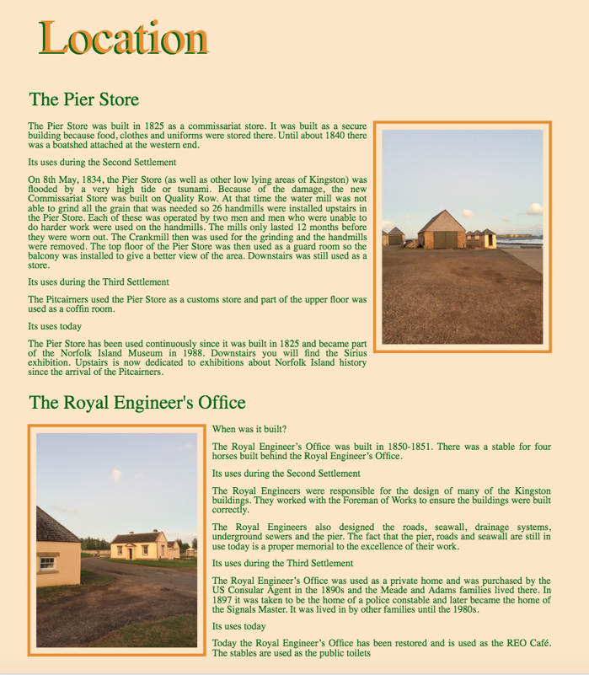

For the fonts, as the Norfolk is the tittle of the website, I style it as my main colour which is green. (Reason why green is main colour: green is easier to be see instead of beige.)



I have four h2 which are Introduction, Description, History, and Location. I put introduction and description in the same page because I think both of them are the elements of first step to understand Norfolk. Thence, history and location have their own pages.

However, h3 only appear on Location section due to there’s many small title need to be show up before the whole article.

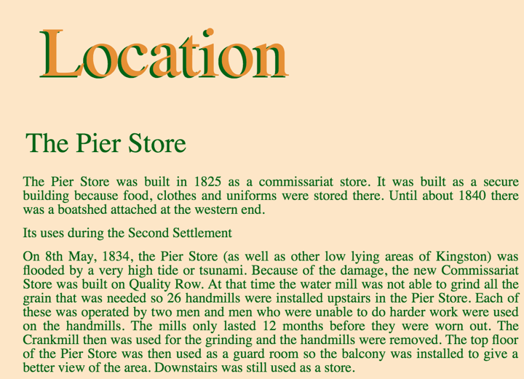

I did put a hover for my image at Introduction section. Opacity 0.6 when it isn’t hover, it can outstanding the title “Introduction”. The reason why I make opacity 1 for hover is because audience might want to see the clearer image.

When it’s hover, opacity is 1:

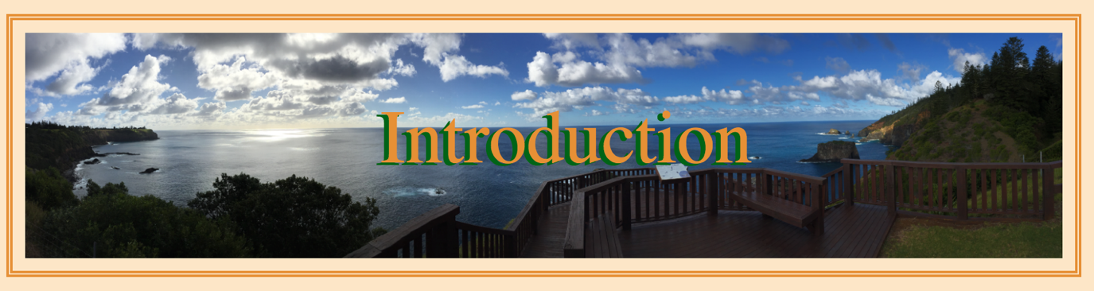

When it isn’t hover, opacity 0.6:

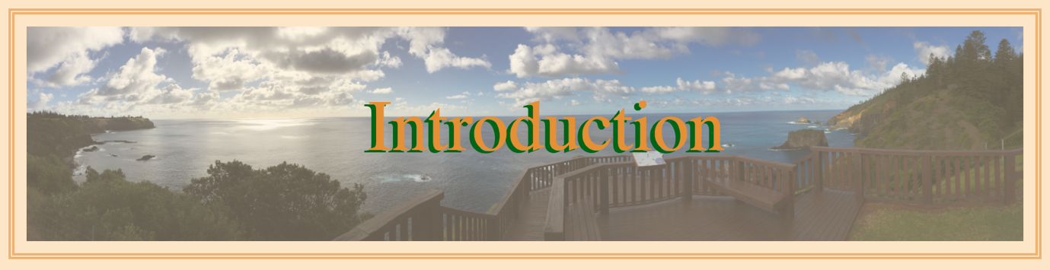

There’s many problems I face when I was doing this assignment. For example, my words doesn’t show up the colour I set.

This is my header:



This is my footer:

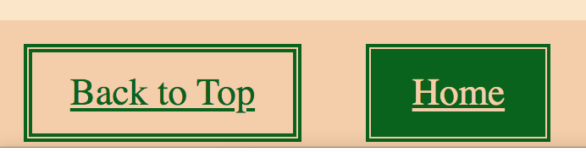

My header should look like my footer (I set them same style.) As my font should be green and beige background, and font turn beige, background turn green when its hover. But my header doesn’t show up what I want. Seems like there’s no any solution so I asked Riley how to fix it. And he said that I should style the <a> inside the <li> instead of the <li>.

Beside, there’s also an issue struggling me for a long time. In the final assignment, to demonstrate my understanding of wed design and to develop, I want to put a title inside my photo. But I never can make the words “Introduction” be inside the picture.

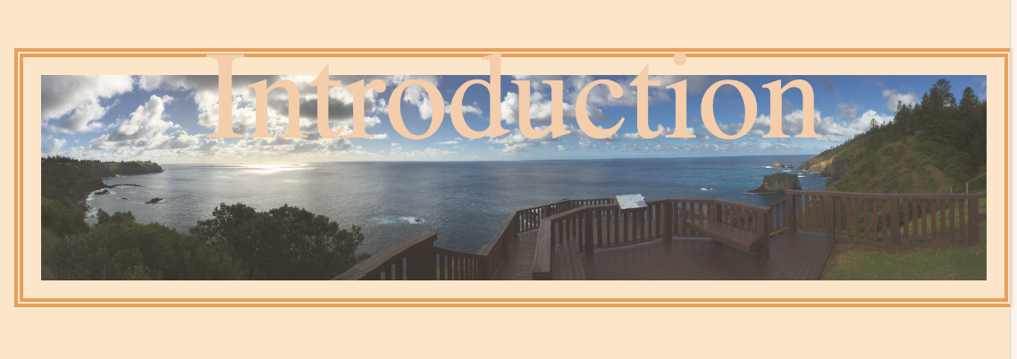

Riley has fixed it in the tutorial of week 12, which I have to delete the column in navigation. Because we don’t need to insert column in navigation but we already can make a column from there. Second thing is to style {clear: both} in container, so that it can ignore them. Riley had hide some of my mistake in my CSS style, but I did not delete it because it can remind me I were doing some mistake over there. I also put {top: 20% bottom: 20%} for it to make it always stay at middle. I was using <div> for my word “Introduction” but Riley change it to <h2> because it is a title and it should be h2 instead od <div>.

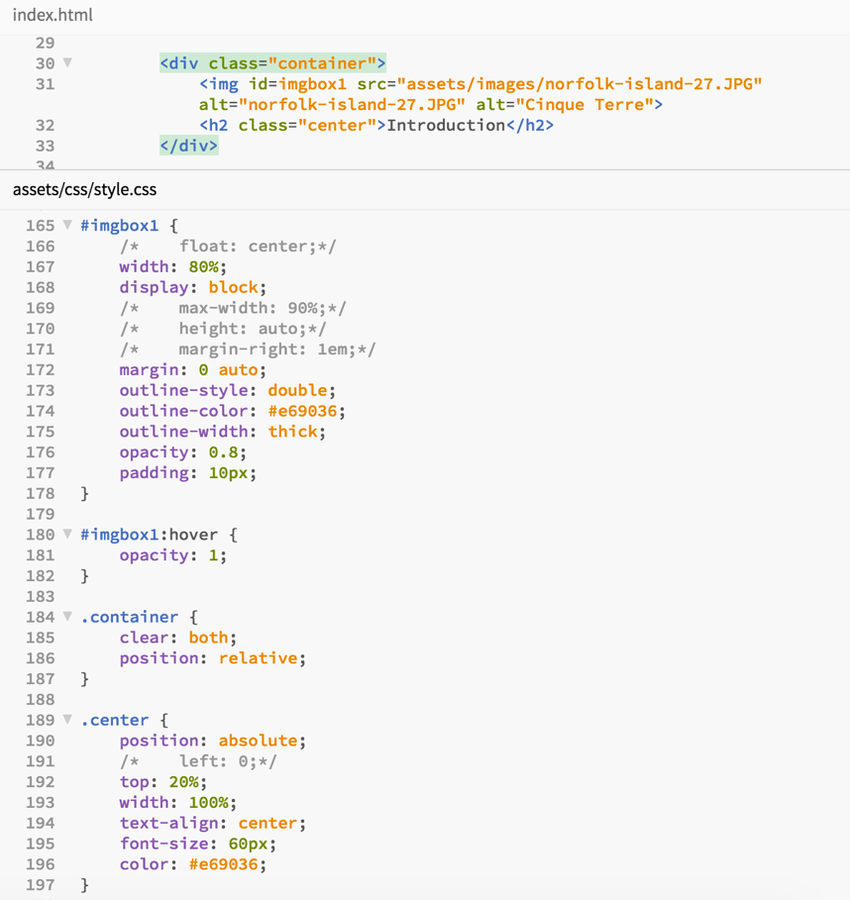

This time, I learned something new which is float something in right, left or center. Some photo had been float on right or left beside the article.

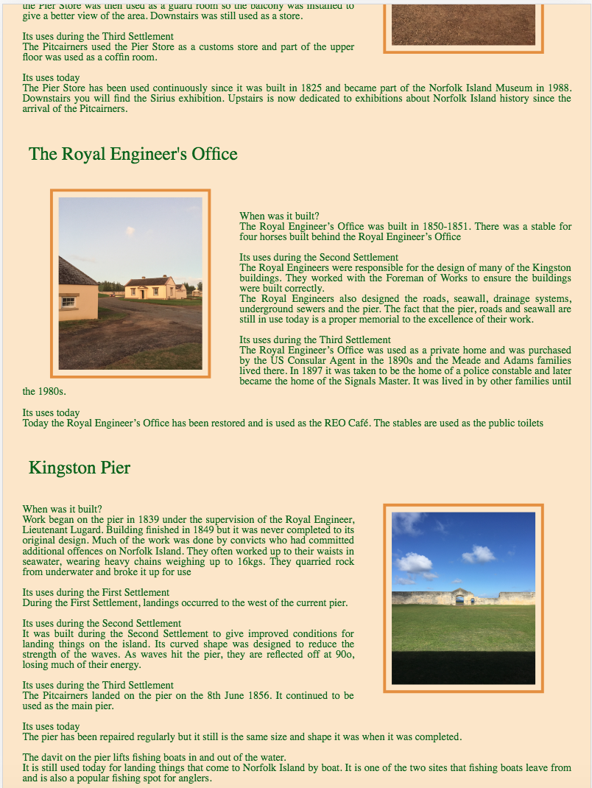

Also, there’s a trick skill I learned which is styling the opacity for the image. When it’s hover, my picture turn opacity 1, which is clear version.

Opacity:0.8:

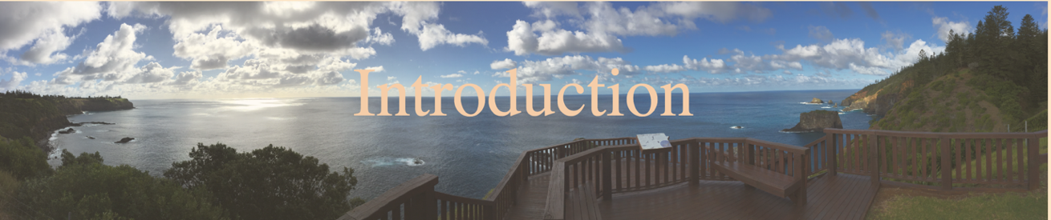

(Hover)

Opacity: 1:

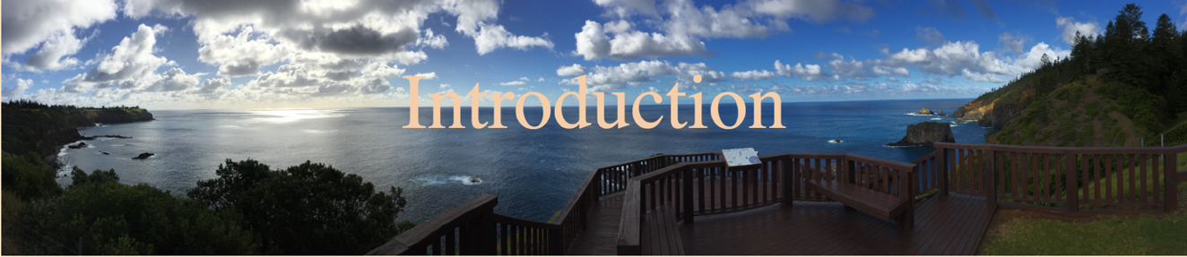

I want to put three image side to side each other. But I had figure it out for a long time, and finally, I found the solution which I have to <div class=“column”> to every image I want them to be together, then style column with width:33.33% in CSS. If it’s 4 images, we should put 25%. (it depends on how many image you want to put together.)

From this:

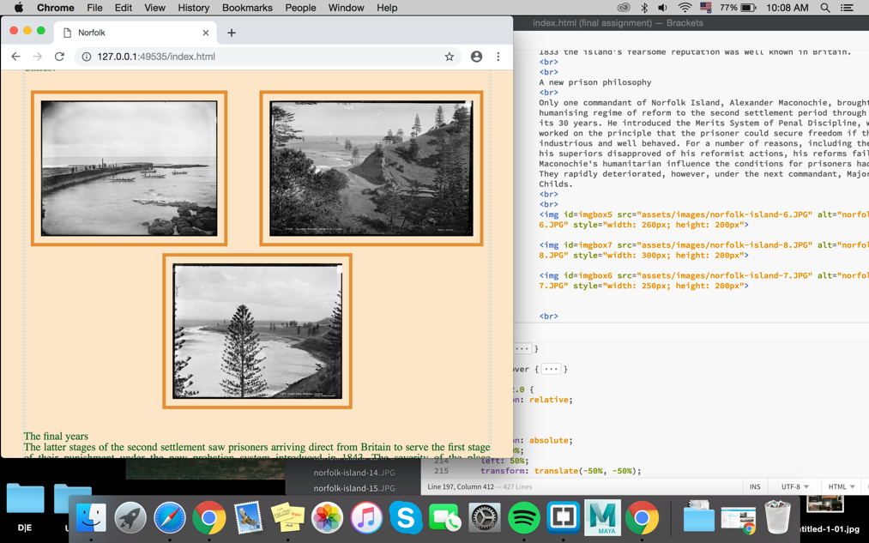

To this:

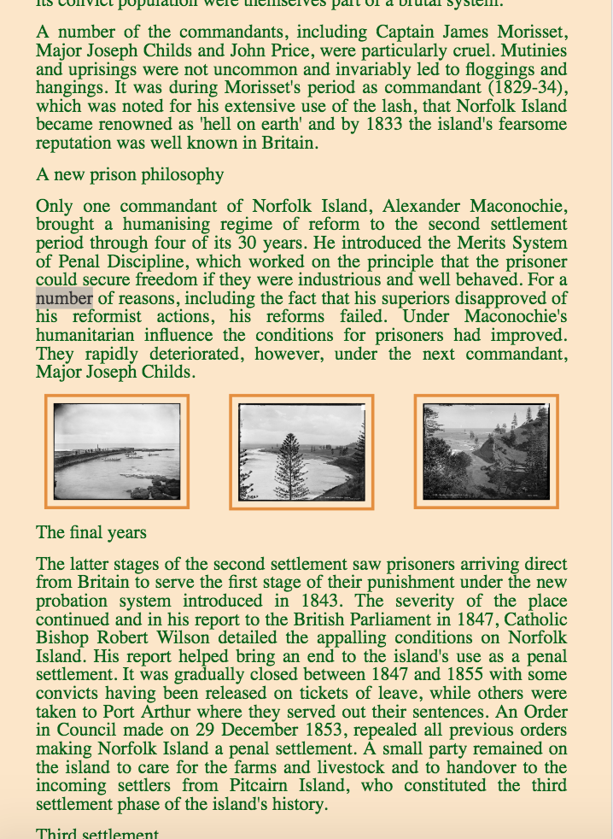

I also style some of my image border radius as 50% which means round border. Styling the whole picture as square is kind of boring, thence, using some round border might grab attention.

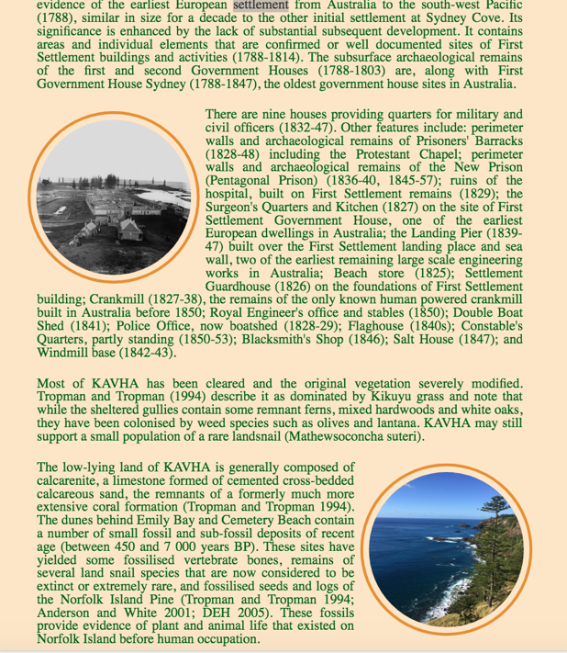

How I code html and style css for the image side by side:

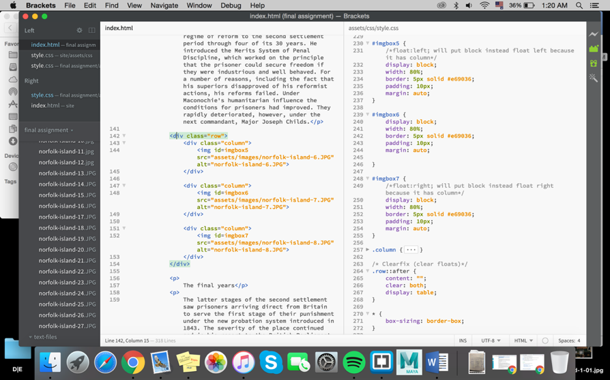

Full of words might make audience stop browsing the website, so combine text and image together can grab some attention. Thence, I did learned another skill from w3school.com which is to create a transparent Image text.

Reference this:

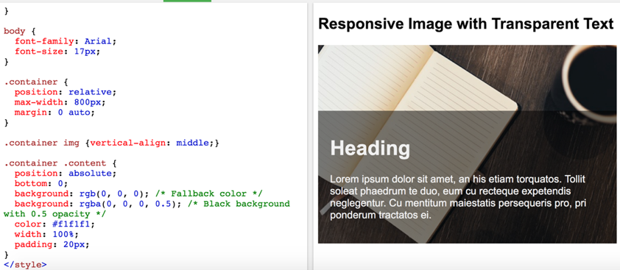

To make this:

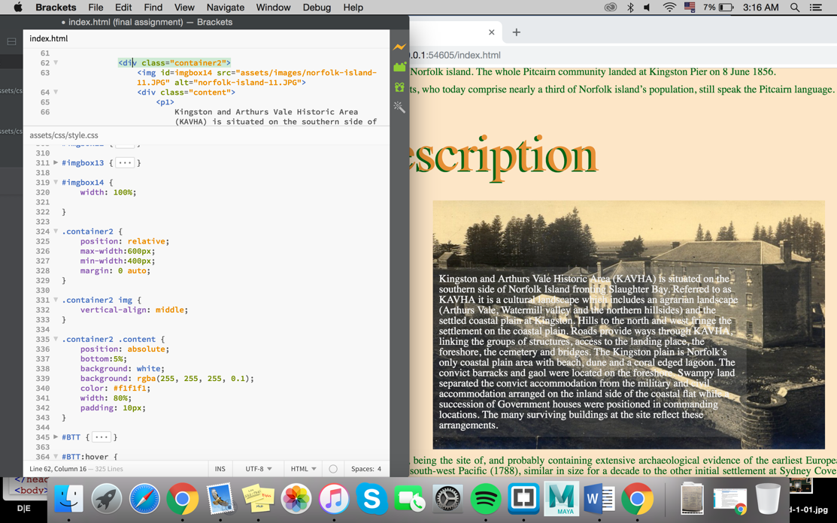

I get this error when I do the validation, the solution is to key in <meta charset= “utf-8”> and <meta name= “viewpoint” content= “width=devide-width, initial-scale=1.0” >

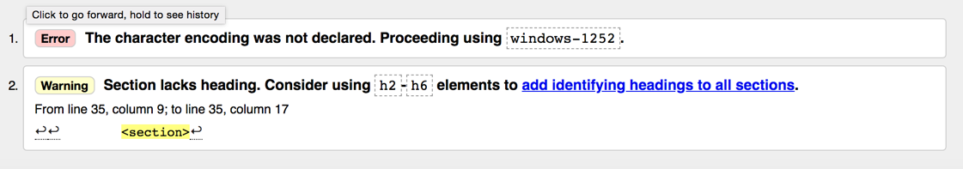

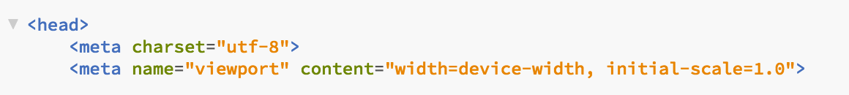

Accessibility:

WCAG 2.0 test

WCAG test is a very important step in web design. It must be done before the website is publish. This accessibility testing is not only focus on verifying usability but also make sure the website can be used by disabilities, neurological and more. One of the test is audio control. If the audio on a website plays automatically, it might shocks the user of the people around the user. It should have a button to stop the music or lower down the volume. Some people make website and publish to public, they should take it serious of doing this kind of usability and accessibility test.

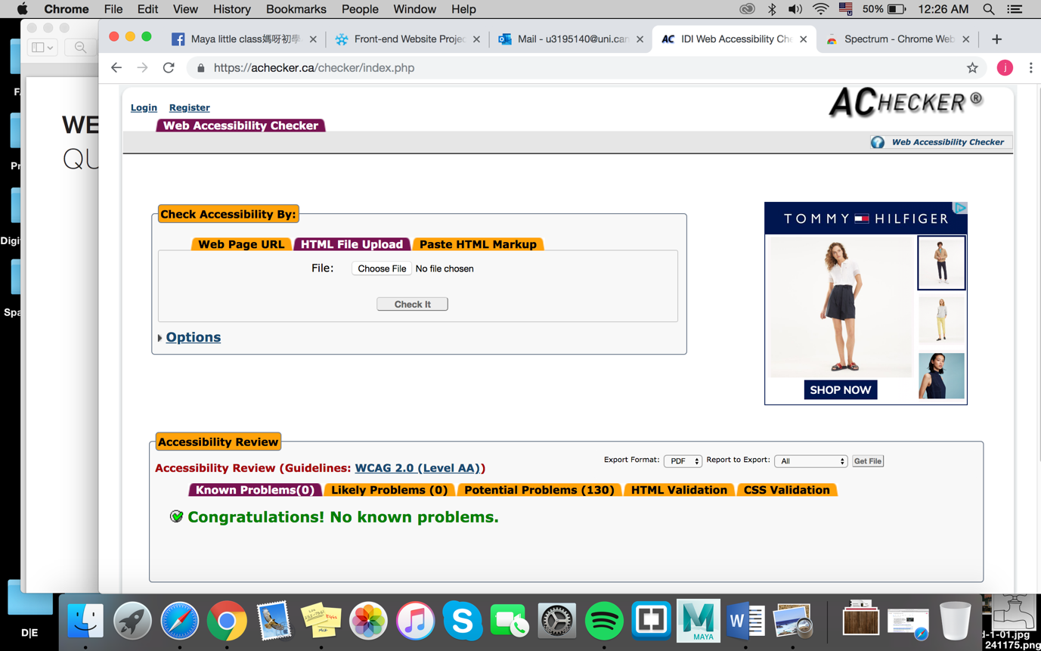

|  |  |
| --- | --- |
| * + 1. Non-text Content   (Provide text alternatives for non-text content) | Fail  (my only non-text content is images, I have no idea what name is the images and Riley had said we don’t need to do this in this assignment; But I understand the important of this requirement. Non-text content without any text explanation will confuse the audiences.) |
| 1.3.1 Info and Relationships  (Logical structure) | Pass  Information has a logical structure, which can be recognised and followed by browsers. |
| 1.3.2 Meaningful Sequence  (Present content in a meaningful order) | Pass  All the text, image is arranged by neat and tidy. There’s some gap in between, thence, it will be easy to browse. |
| 1.4.1 Use of Colour  (Don’t use presentation that relies solely on colour) | Pass  Colour is not used as the only visual means of conveying information. In every button, it will change colour when it’s hover. The purpose of it is to give a direction for the user that they are pointing the button. |
| 1.4.2 Audio Control  (Don’t play audio automatically) | Pass  There’s no audio in this website. |
| 2.1.1 Keyboard  (Accessible by keyboard only) | Pass |
| 2.1.2 No keyboard Trap  (Don’t trap keyboard users) | Pass  There’s no keyboard trap in this website. Everything is fine by using either keyboard or touch screen. |
| 2.3.1 Three Flashes or Below  (No content flashes more than three times per second) | Pass  There’s no any flashes in this website. |
| 2.4.2 Page Titled  (Use helpful and clear page titles) | Pass  Titles that describe topic or every section can be spot in the website. |
| 2.4.3 Focus Order  (Logical order) | Pass  There’s border in every images, and the title of the website. Content that users can select or interact with is in logical order. |
| 2.4.4 Link Purpose *In context  (Every link’s purpose is clear from its context) | Pass  Every link has a button on there so that is will easier to access to another page. |
| 3.1.1 Language of Page  (Page has a language assigned) | Pass  The use of language must be readable and easy understanding. In this site, I was just using human language. |
| 4.1.1 Parsing  (No major code errors) | Pass  No major code errors. |

Contrast checker

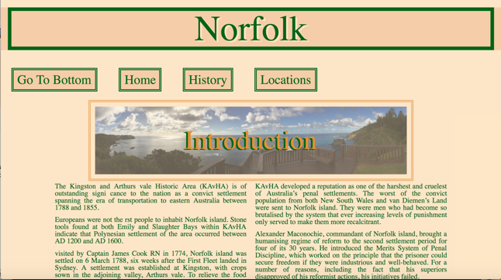 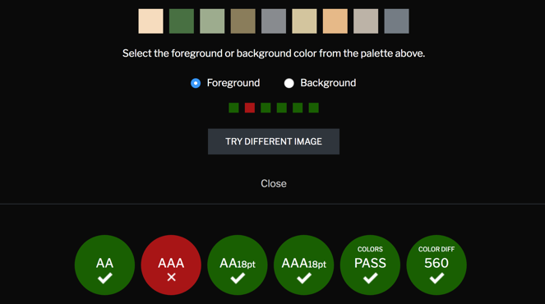

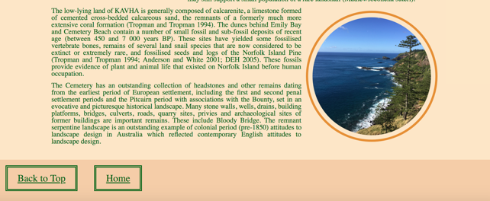 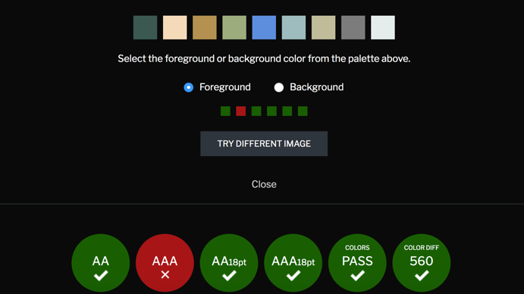

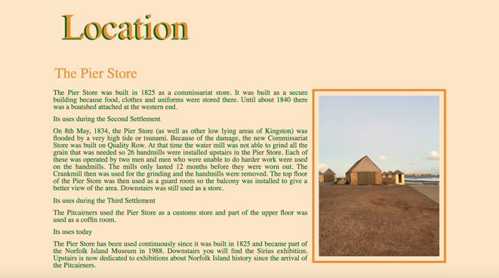 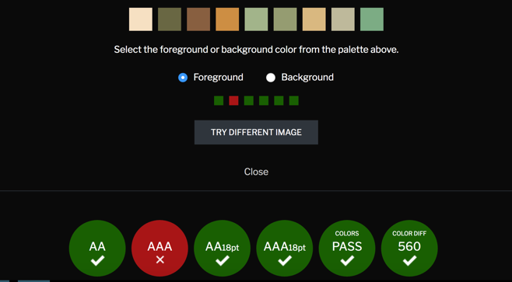

W3C Markup Validation

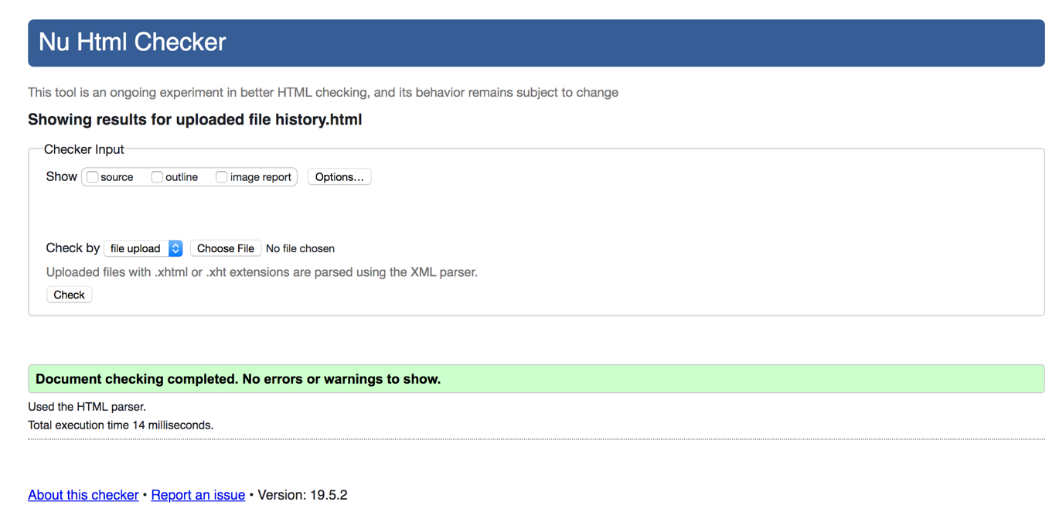

W3C CSS Validation

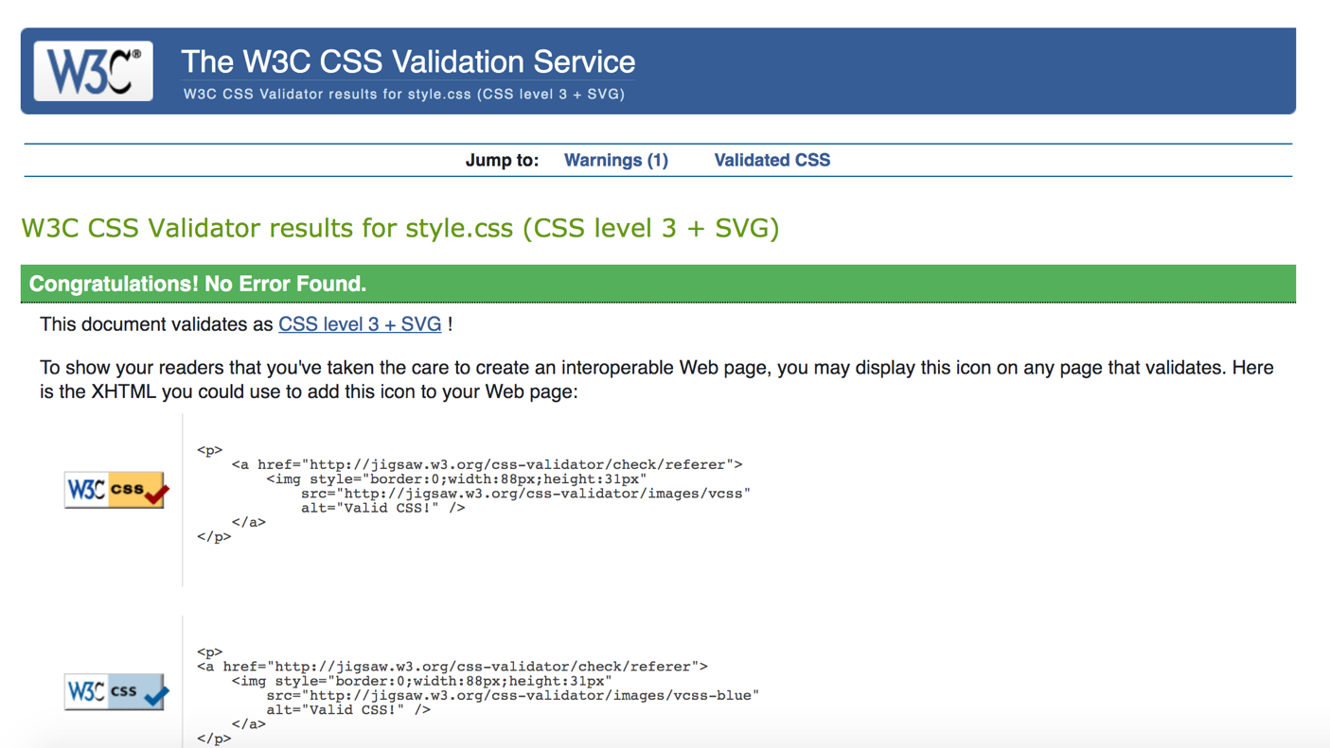

Wave result

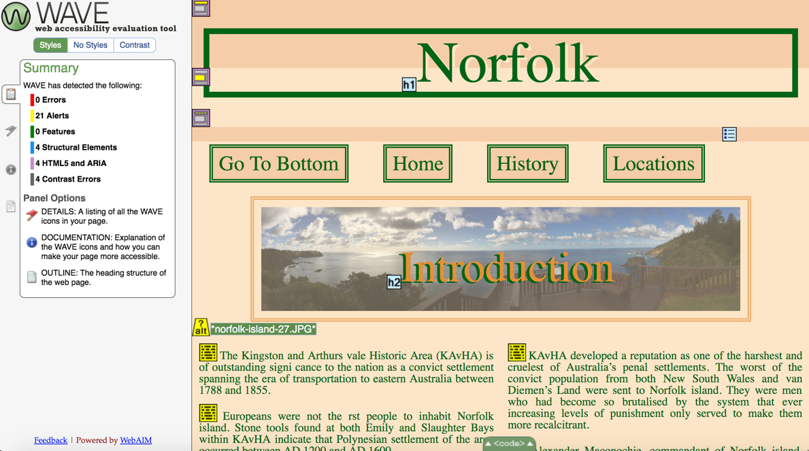

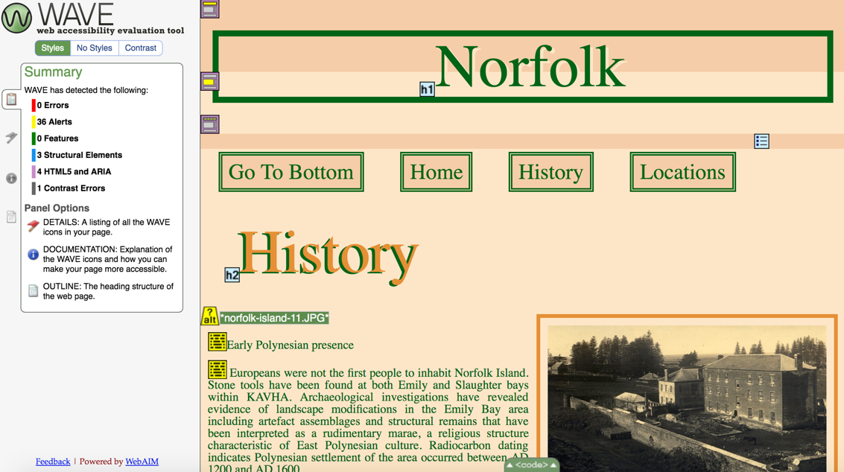

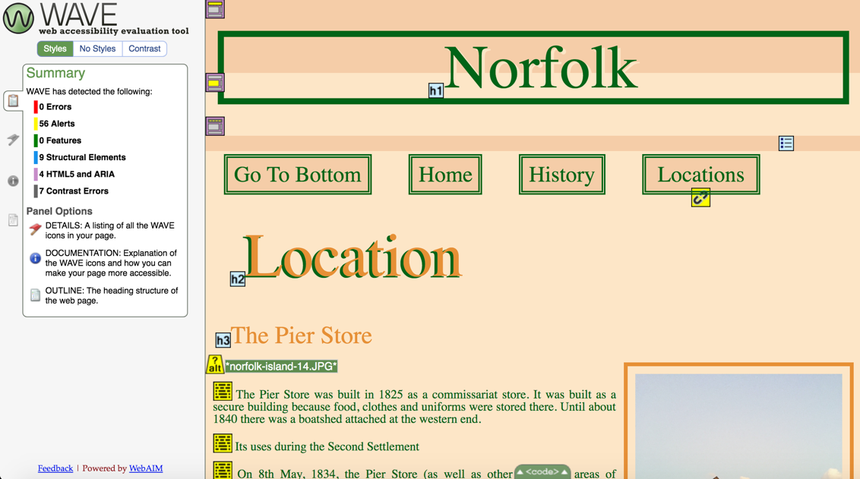

References link:

<https://www.w3schools.com/css/css_align.asp>

<https://www.w3schools.com/css/css_float.asp>

<https://www.w3schools.com/css/css_image_transparency.asp>

<https://www.w3schools.com/css/tryit.asp?filename=trycss_image_text_center>

<https://www.w3schools.com/howto/tryit.asp?filename=tryhow_css_images_side_by_side>

<https://www.w3schools.com/howto/tryit.asp?filename=tryhow_css_image_transparent_bottom>

<https://www.w3schools.com/css/tryit.asp?filename=trycss_ex_images_circle>

wireframe link:

<https://wireframe.cc/QXOx6T>